Dynamics of rock arches

Ambient vibration and deformation monitoring

Helicopter generated infrasound
Did you know that helicopters produce infrasound? This sound energy is too low frequency for humans to hear but is in most cases the strongest sound that helicopters generate.
The main rotor of a helicopter produces sound into principal ways: The first is called “blade slap” which is what we hear. That sound is produced when an advancing blade strikes the air wake produced by the preceding blade, but it is not the strongest sound. The strongest sound is produced as so-called “thickness noise,” which arises due to pressure pulses emitted from the front and trailing edges of a rotor blade, and through constructive interference of these pulses as they reach a target. This sound energy is strongly directional, emitted in the plane of the main rotor.
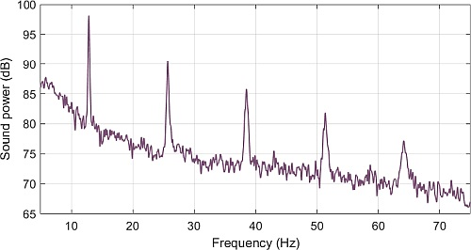
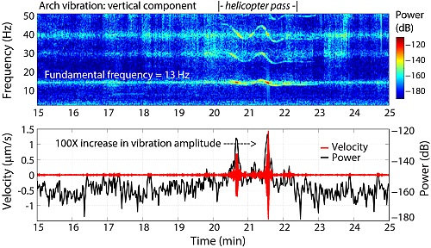
The frequency of infrasound is controlled by the number of blades on the main rotor and the main rotor revolution rate, and the lowest infrasound tones are between ~10 and 30 Hz. Top is a plot of the sound spectrum generated by a two-blade Bell 206 helicopter. In it you see the first frequency peak at 13 Hz with a series of overtones at integer multiples. During flight these frequencies may also be Doppler shifted.
Helicopter infrasound is known to generate resonant vibrations in objects (e.g. an arch above), and past studies have shown that vibration amplitudes can reach potentially damaging levels in ancient structures, for example adobe walls, in addition to rock pinnacles (King 1996, King 2001). To learn more about helicopter induced resonance see: Moore (2018) Rainbow Bridge Vibration Risk Assessment

