XX/XX/ 2021
To
The Honourable Meaghan Scanlon
Minister for the Environment and the Great Barrier Reef and Minister for Science
via email
environment@ministerial.qld.gov.au

Re DA Number: MCU20/0006

Dear Minister,
As a resident of Mission Beach(?) I/we would like to bring to your urgent attention a development that has been approved by both the Cassowary Coast Regional Council and the State Government that did not trigger a Queensland Government environmental assessment.
The following maps show the obvious and unacceptable impacts an industrial helicopter base would have on matters of State Environmental Significance (MSES) including the important population of endangered cassowary.

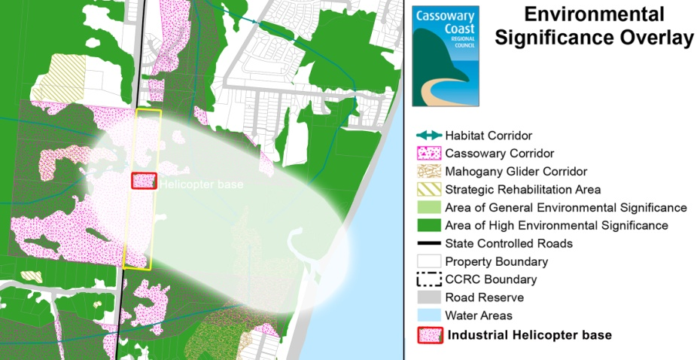
We have written to the Deputy Premier detailing our serious concerns asking him to use his discretionary power under section 91 of the Planning Act 2016 to call-in DA Number: MCU20/0006.

We urge you in your role as Environment Minister to please consult with the Deputy Premier to assist in a proper and robust reassessment of DA MCU20/0006.

Sincerely

Your name
Your address

